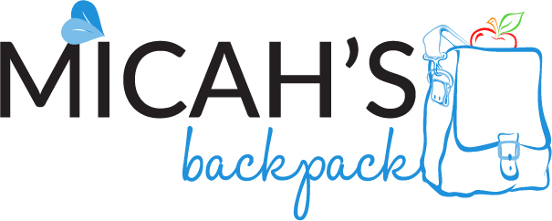

October 2017

Sharing the Story

316 Students

Served in Our Community

|  |  |
| --- | --- |
| **September 2017** | **School Year to Date** |
| 204 Volunteer Hours Shared | 506 Volunteer Hours Shared |
| 1,219 Backpacks Delivered | 2,946 Backpacks Delivered |
| 7,314 Meals Provided | 17,676 Meals Provided |
| 1,064 Food Items Donated | 5,438 Food Items Donated |

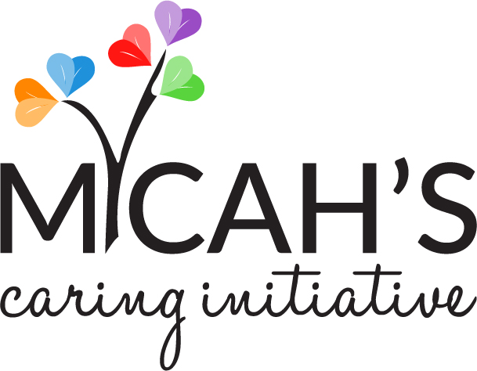

backpack * mobile backpack * closet * garden * seniors