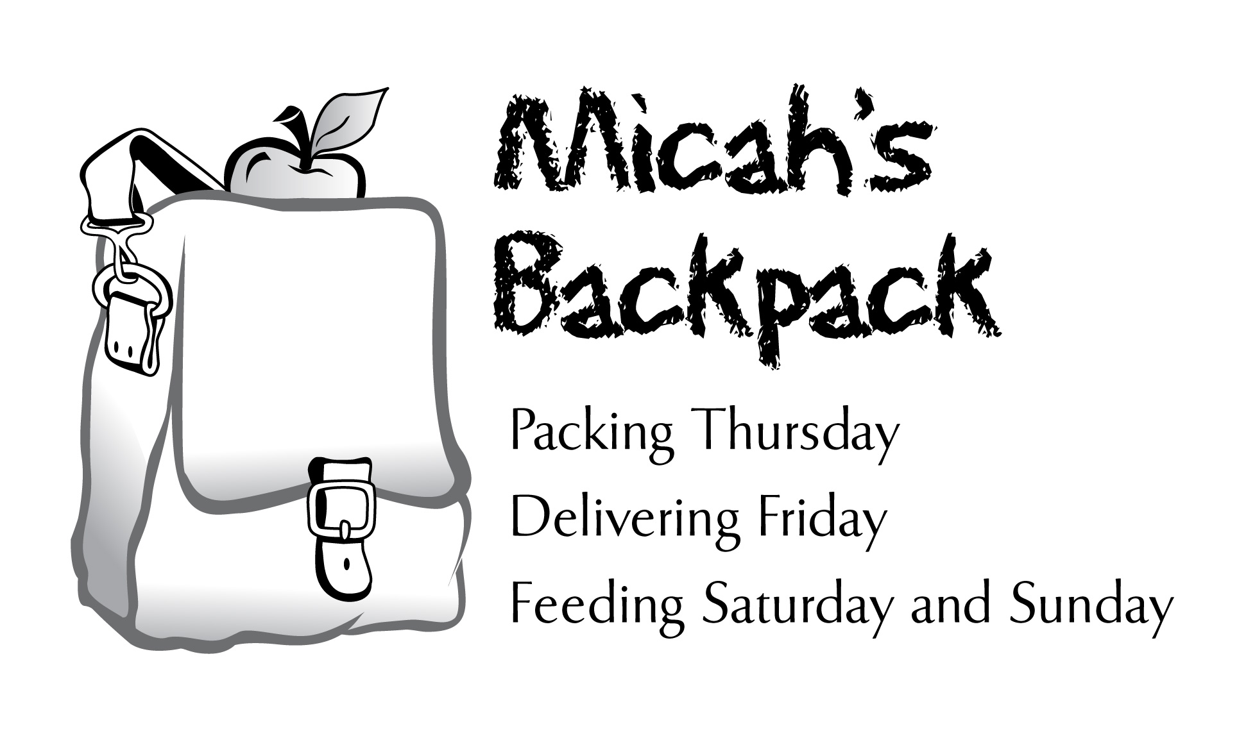

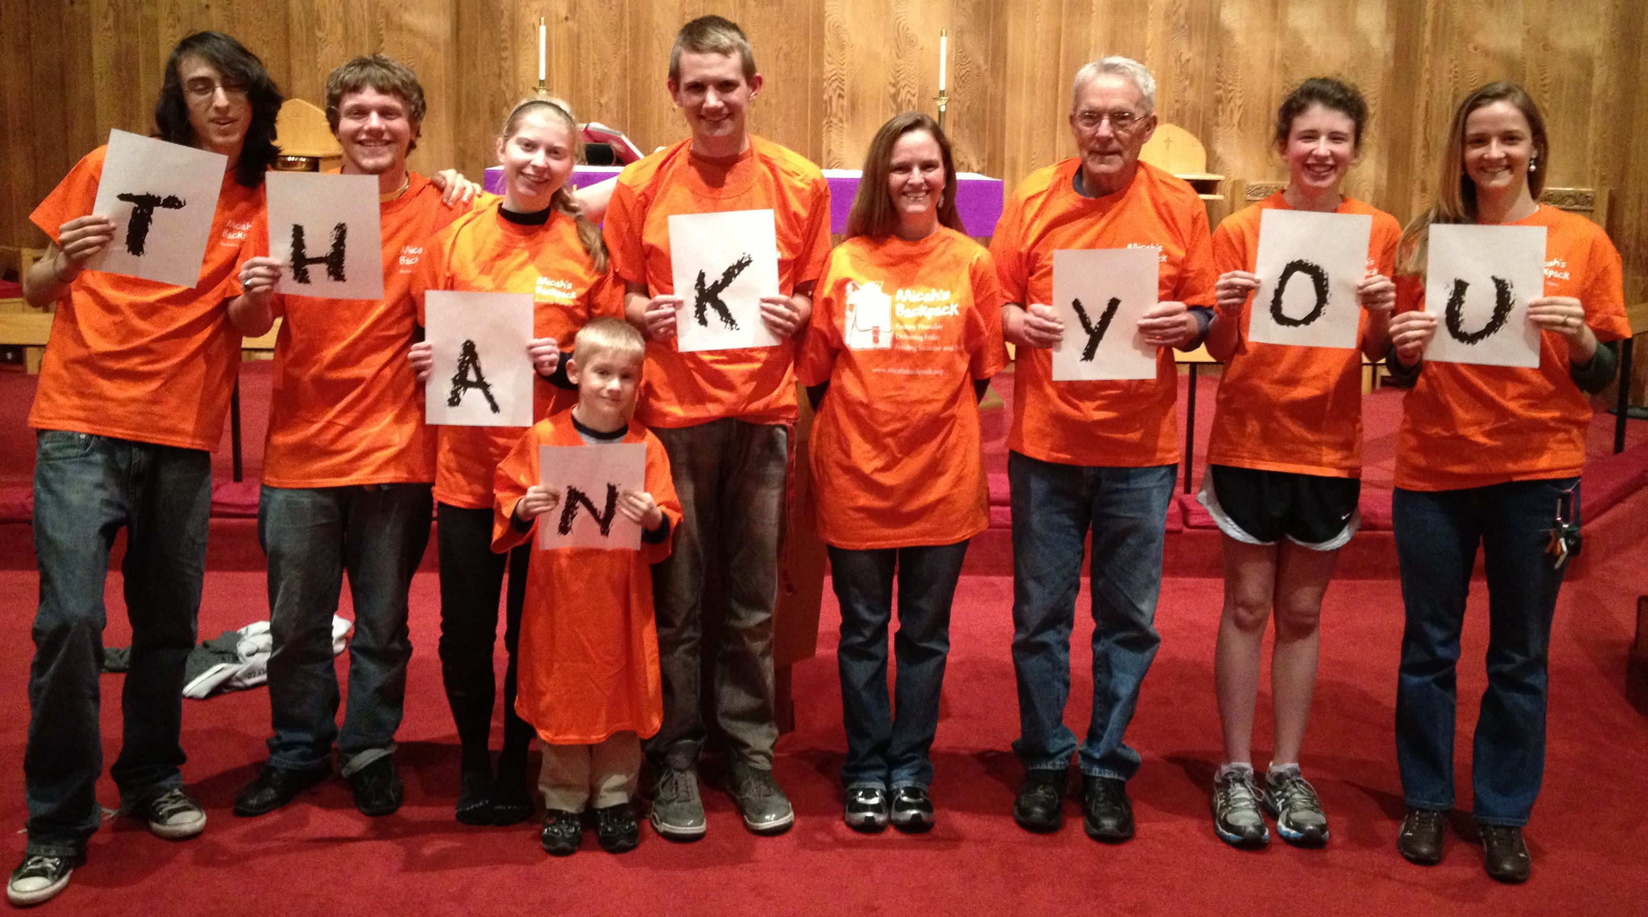
December 2013 Sharing the Story
280 Students in Our Community Helped

Thank you to everyone who makes Micah’s Backpack a fun and rewarding way
to share gifts of food with children in our community.

December 2013 | School Year to Date
254.5 Volunteer Hours | 1,501 Volunteer Hours
870 Backpacks Delivered | 4,064 Backpacks Delivered
5,220 Meals Delivered | 24,384 Meals Delivered
5,552 Items of Food Donated | 13,237 Items of Food Donated

