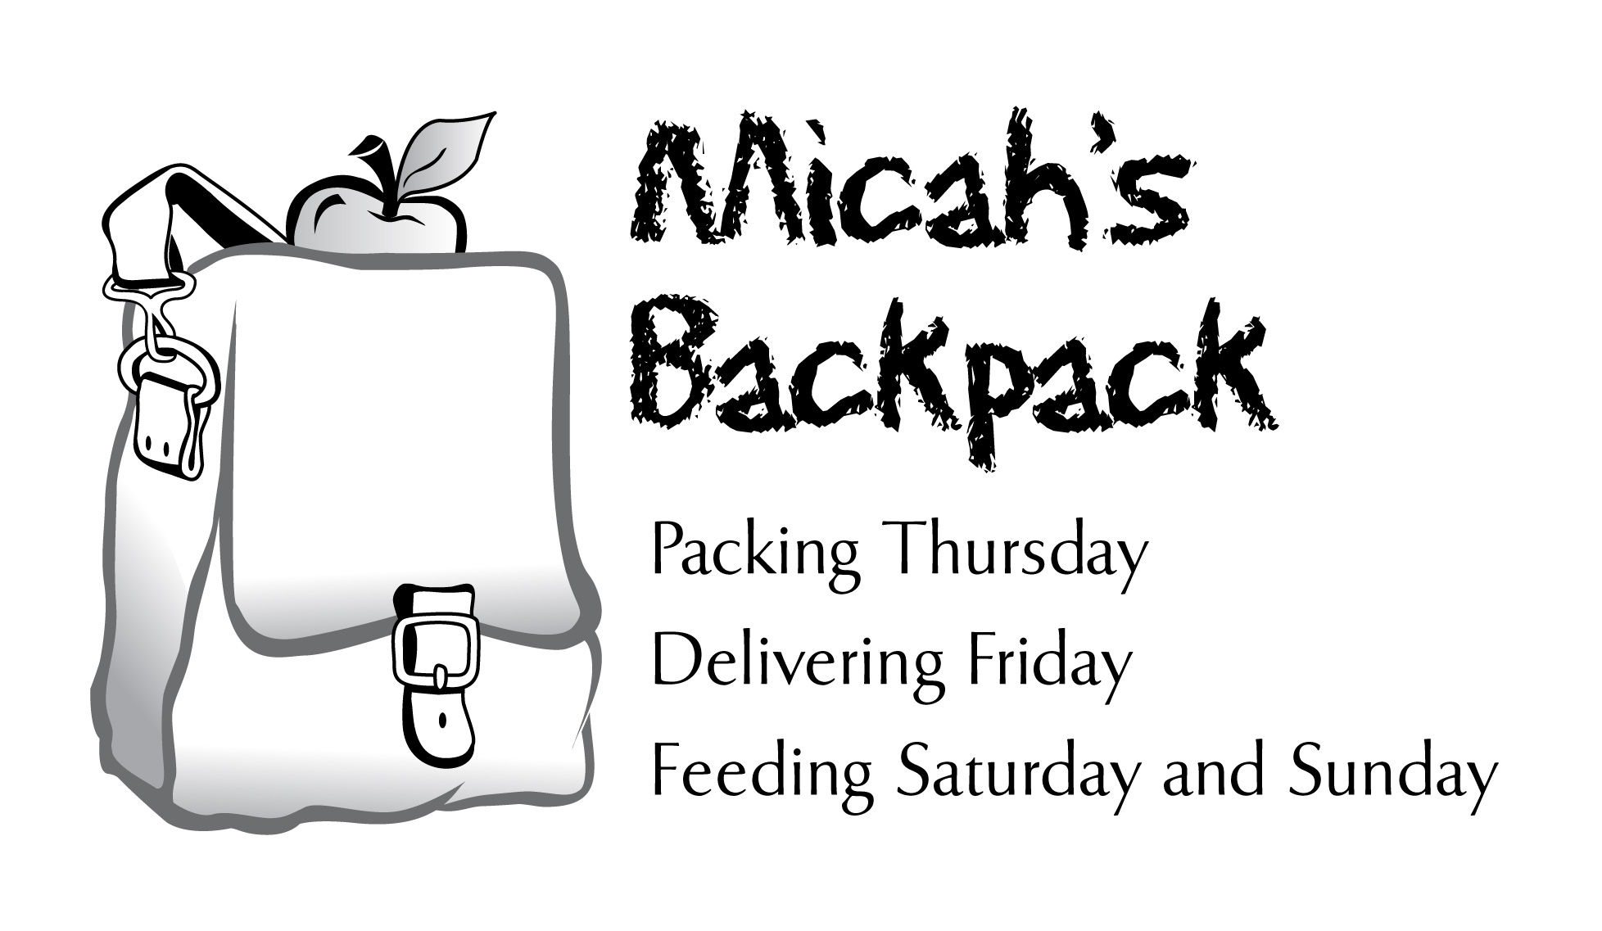

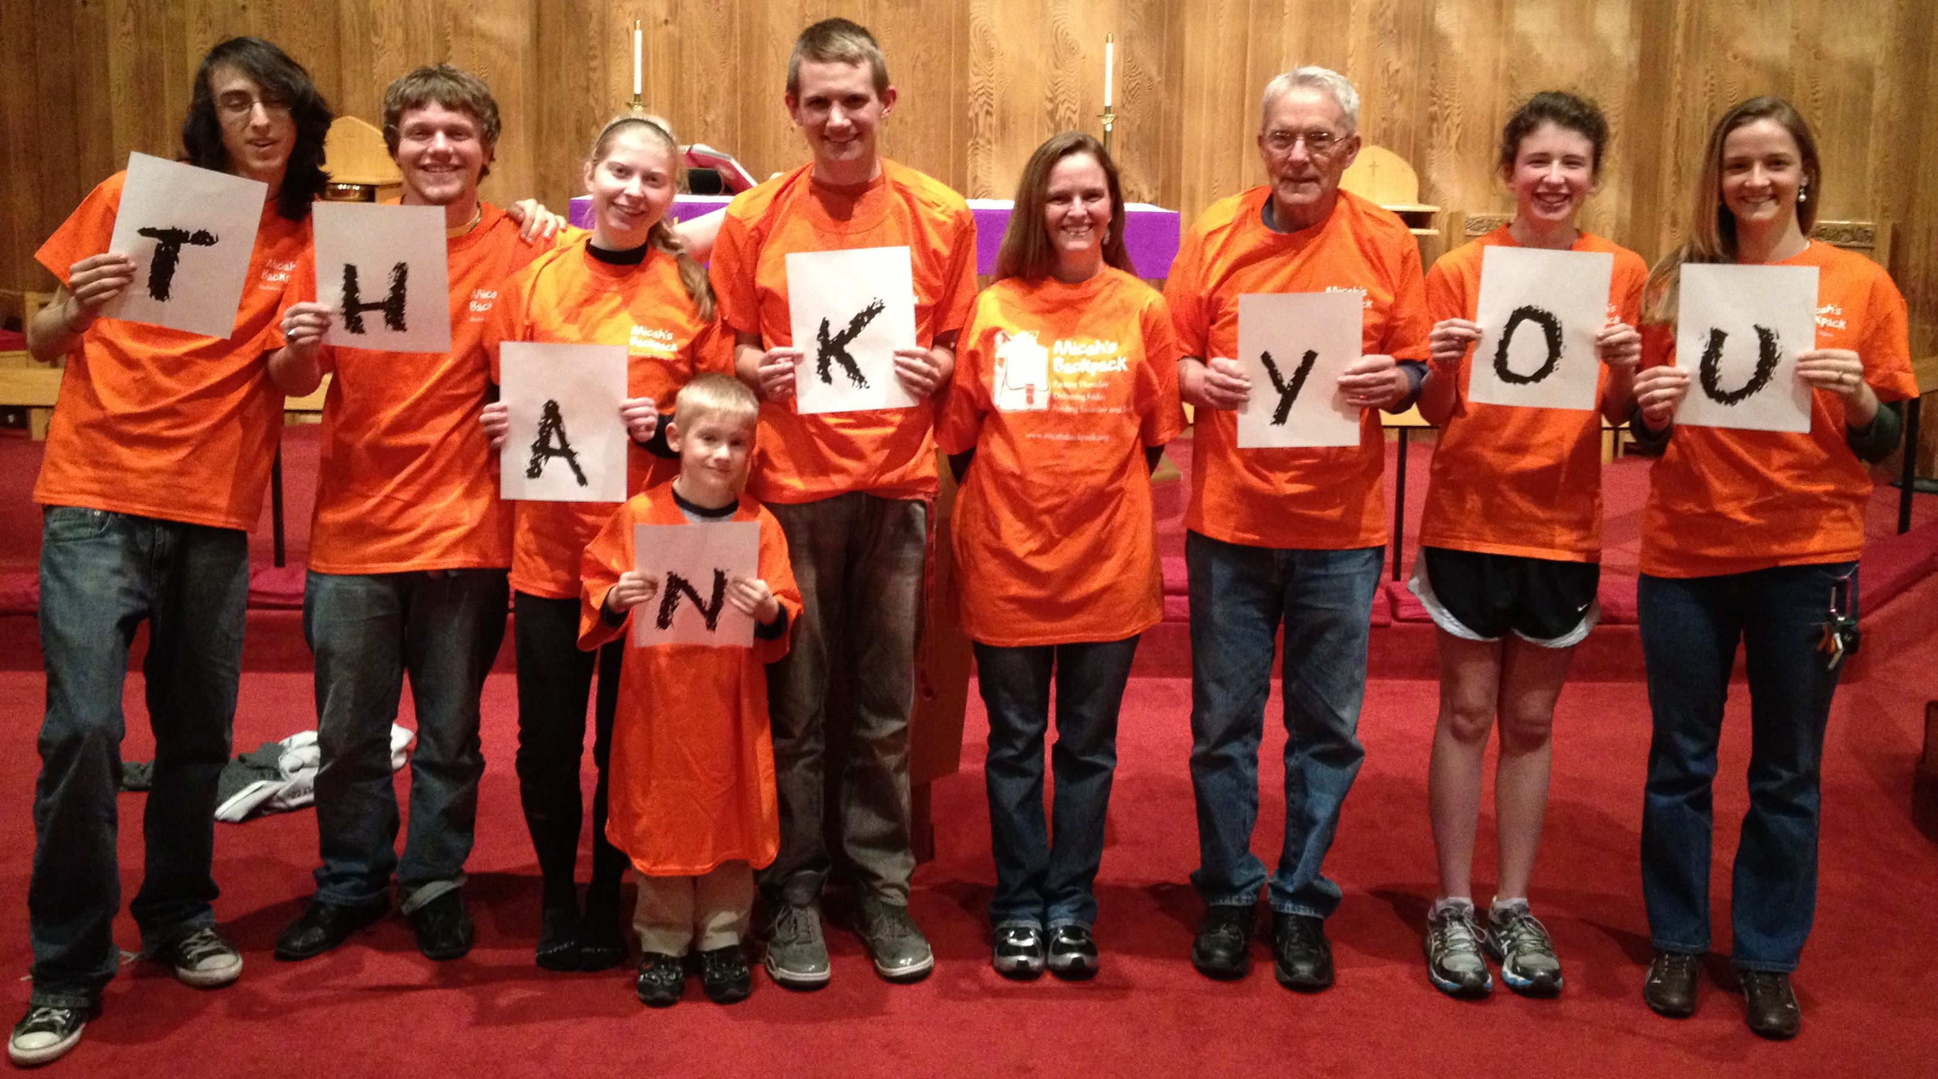
January 2014 Sharing the Story
281 Students in Our Community Helped

Thank you to everyone who makes Micah’s Backpack a fun and rewarding way
to share gifts of food with children in our community.

January 2014 | School Year to Date
291.5 Volunteer Hours | 1,792.5 Volunteer Hours
1,151 Backpacks Delivered | 5,215 Backpacks Delivered
6,906 Meals Delivered | 31,290 Meals Delivered
1,906 Items of Food Donated | 15,143 Items of Food Donated

