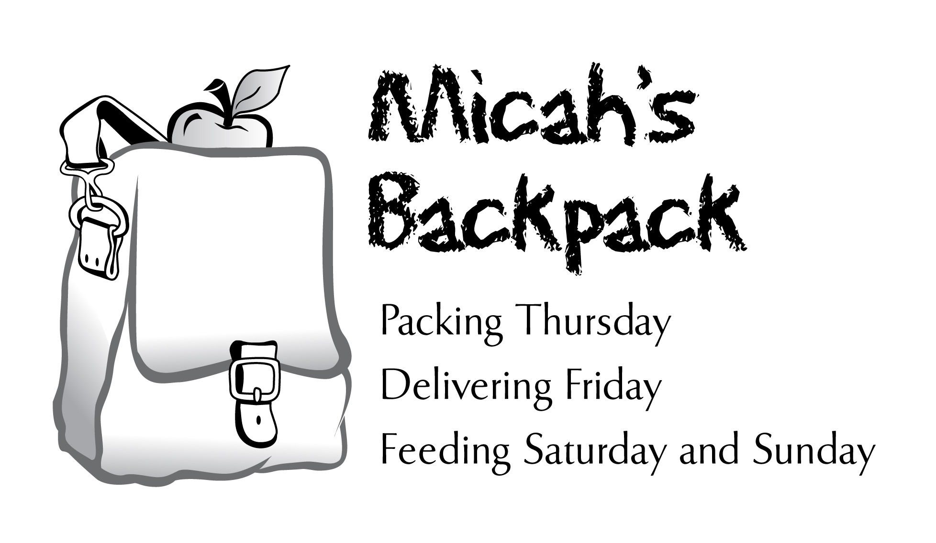

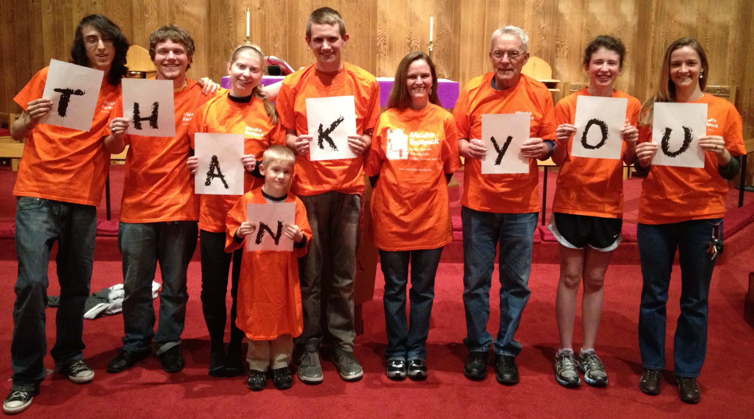
October 2013 Sharing the Story
273 Students in Our Community Helped

This month, a Thursday night volunteer remarked, “it’s wonderful how
Micah’s Backpack brings so many people together to help children in need.”

October 2013 | School Year to Date
539.50 Volunteer Hours | 827.50 Volunteer Hours
1,332 Backpacks Delivered | 2,100 Backpacks Delivered
7,992 Meals Delivered | 12,600 Meals Delivered
2,078 Items of Food Donated | 5,265 Items of Food Donated

