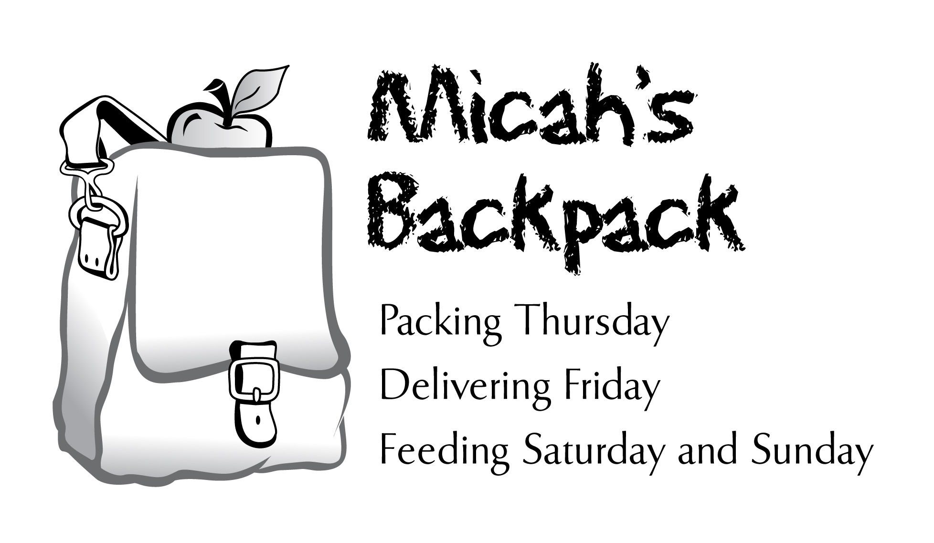
July 2013 Sharing the Story

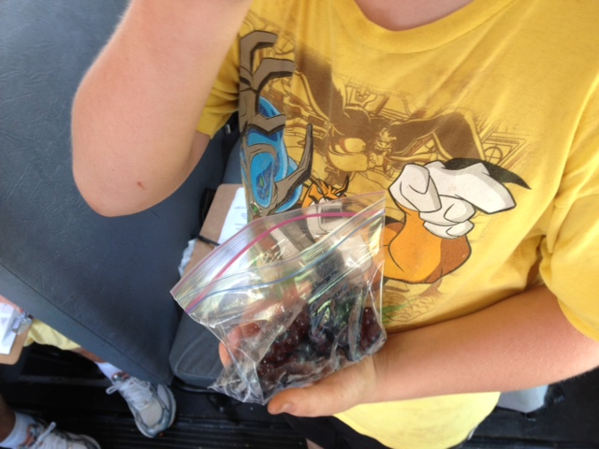
Our friends at 3 Birds Berry Farm encouraged their pickers to share blueberries
with the kids who visit Micah’s Mobile Backpack. For two weeks in July they gave over 50 lbs of blueberries!

July 2013 | Summer to Date
243.5 Volunteer Hours | 486.25 Volunteer Hours
549 Backpacks Delivered | 936 Backpacks Delivered
3,294 Meals Delivered | 5,616 Meals Delivered
454 Items of Food Donated | 2,793 Items of Food Donated

Please let me know if you’d like information about helping in the summer with Micah’s Mobile Backpack!

