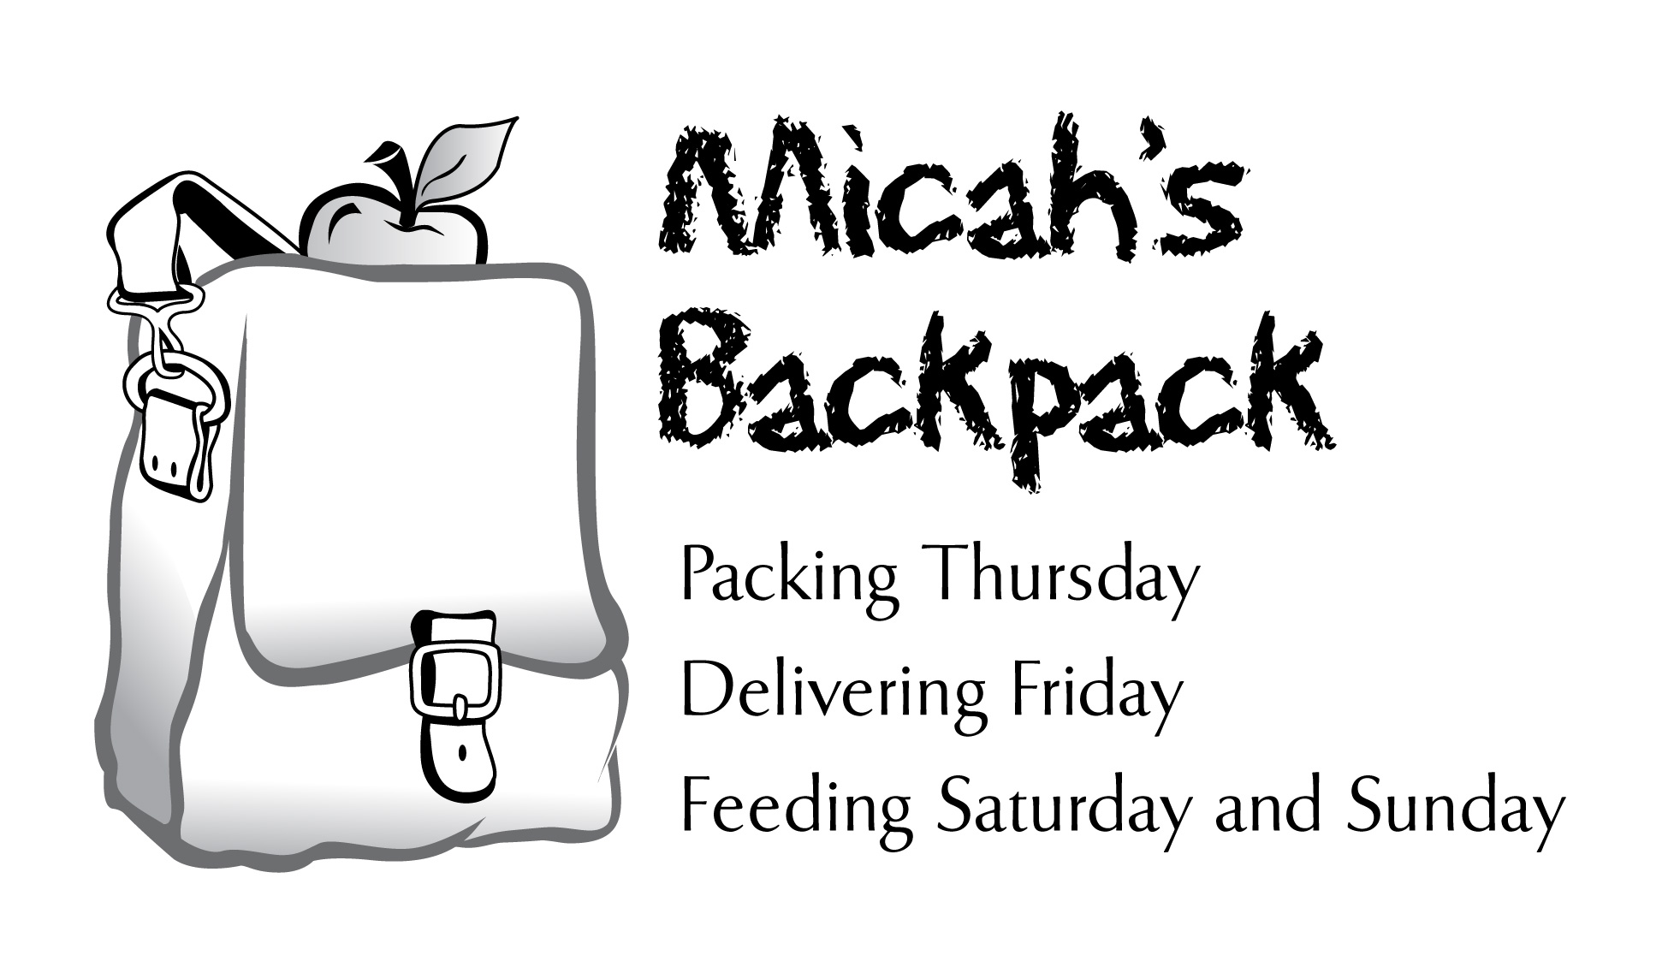
January 2013 Sharing the Story

The classmate of a youth volunteer recognized her tshirt
and thanked her for making his weekends better!
239 Students in Our Community Helped
January 2013 | School Year to Date
302.5 Volunteer Hours | 1,818.8 Volunteer Hours
744 Backpacks Delivered | 4,447 Backpacks Delivered
4,464 Meals Delivered | 26,682 Meals Delivered
2,389 Items of Food Donated | 14,407 Items of Food Donated

Thank you for your generous support of
Micah's Backpack!

