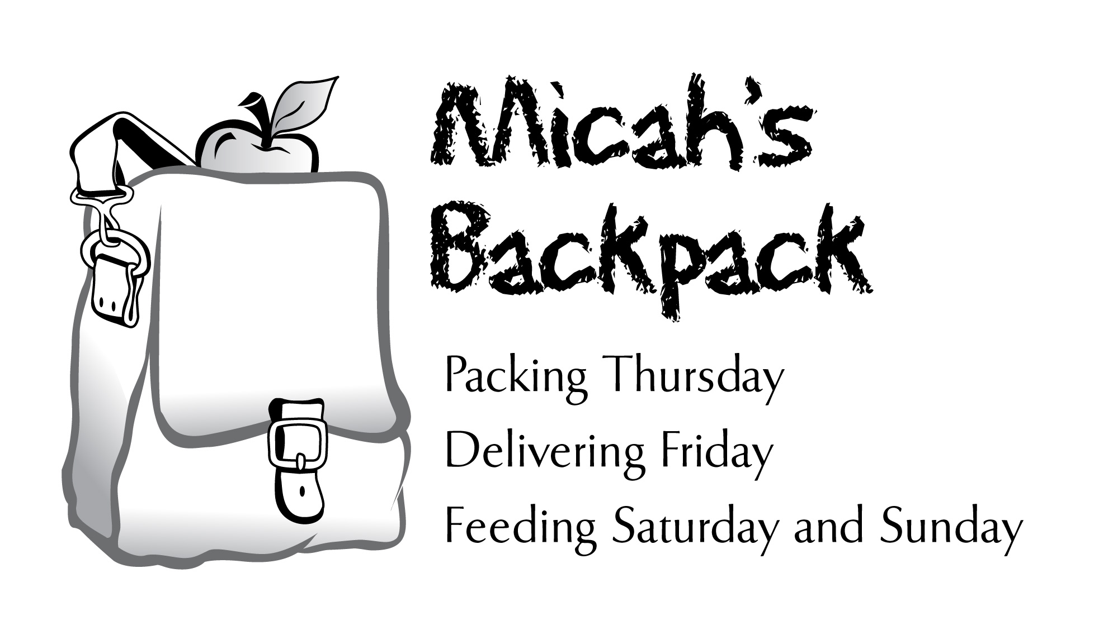
December 2012 Sharing the Story

22 children and youth volunteers helped pack bags
on the last Thursday in December.
Thank you families for growing up caring kids!
236 Students in Our Community Helped
December 2012 | School Year to Date
253 Volunteer Hours | 1,516.3 Volunteer Hours
768 Backpacks Delivered | 3,703 Backpacks Delivered
4,608 Meals Delivered | 22,218 Meals Delivered
2,764 Items of Food Donated | 12,018 Items of Food Donated

Thank you for your generous support of
Micah's Backpack!

